Any inputs to improve the guideline will be appreciated. Send inputs to MaineD@health.gov.za

NIDS review user guide
Open the NDOH Data Dictionary website using the Google Chrome browser: http://dds.dhmis.org
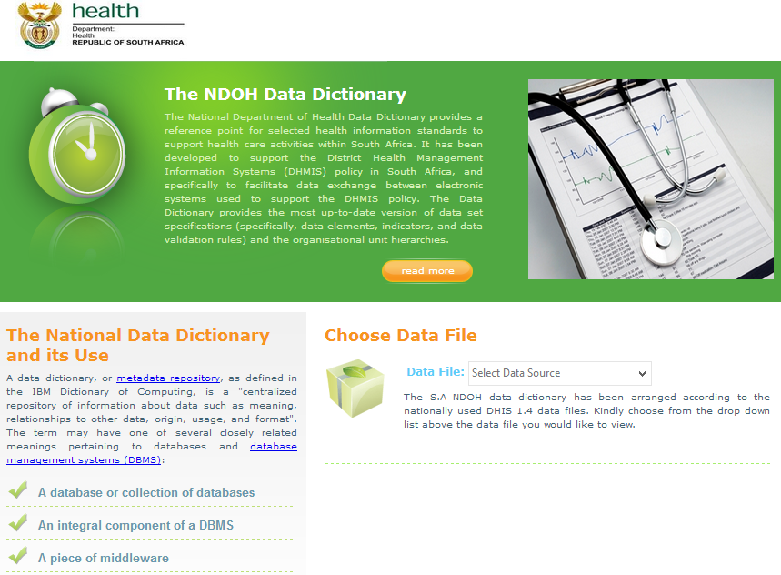
- Login

Click on the Data File drop down menu and click on NIDS Review
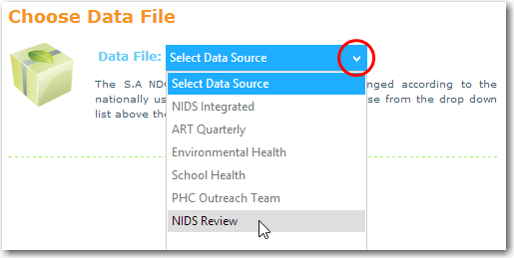
Log in your username and password
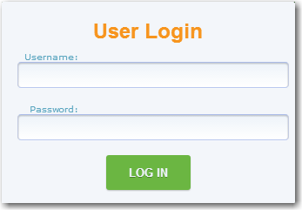
Download the Indicator selection criteria and user guide
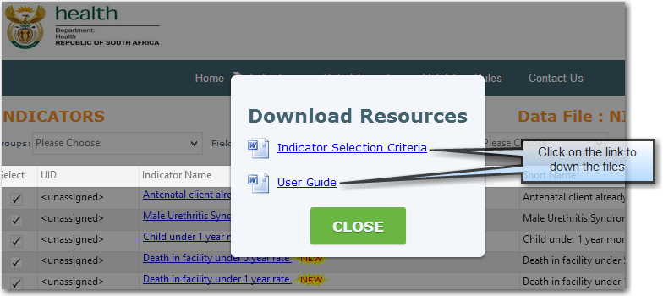
- Filter for Data Elements and Indicators
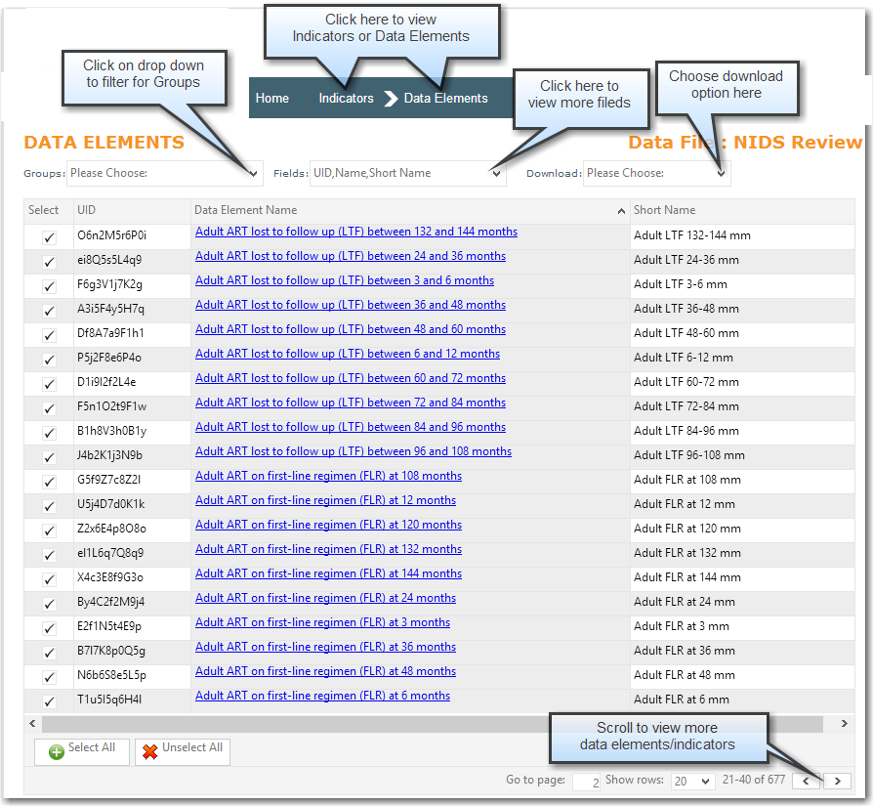
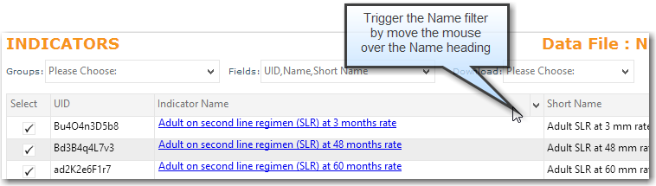
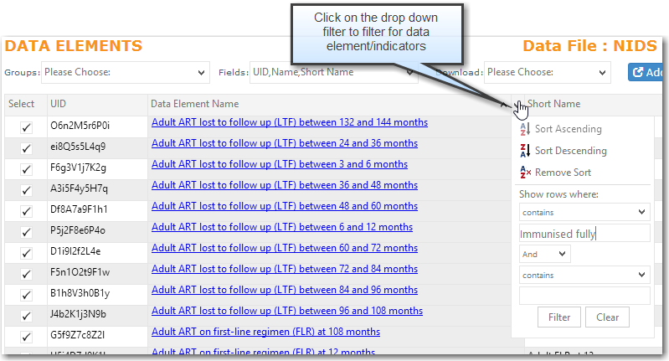
- Vote and add recommendations
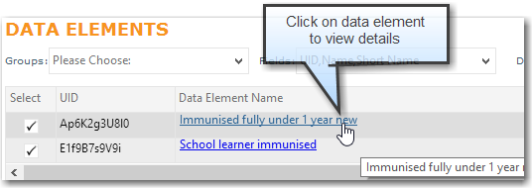
When you click on the Data Element/Indicator it will then open a new page.
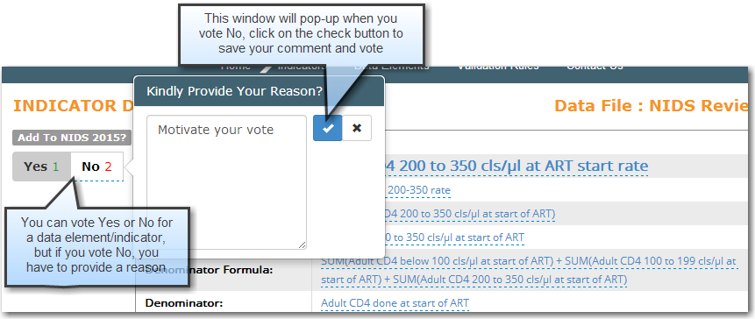
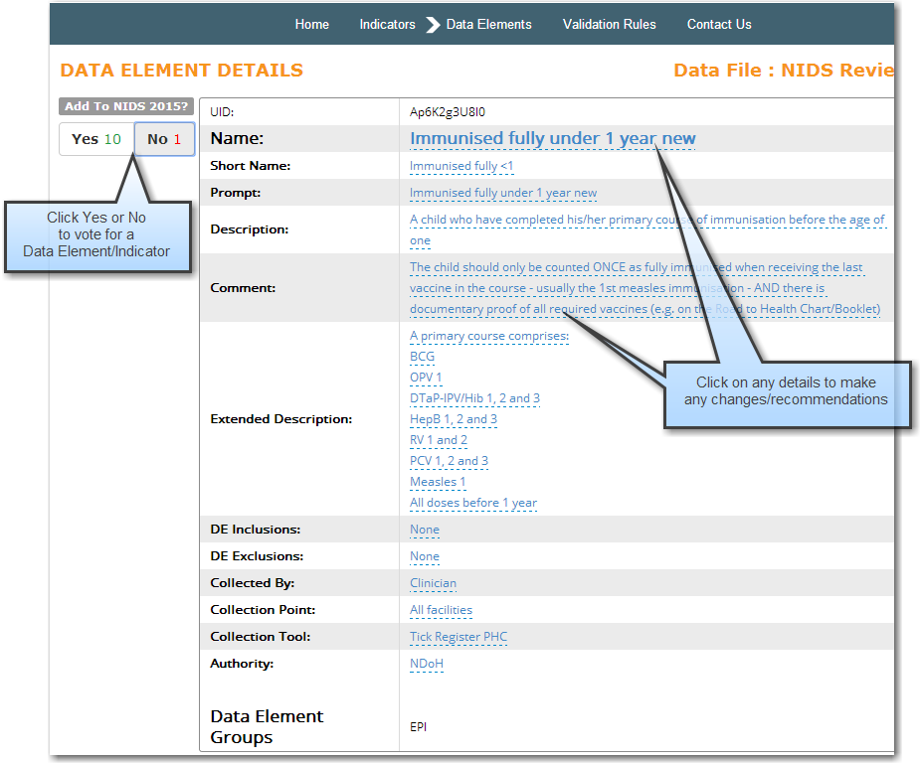
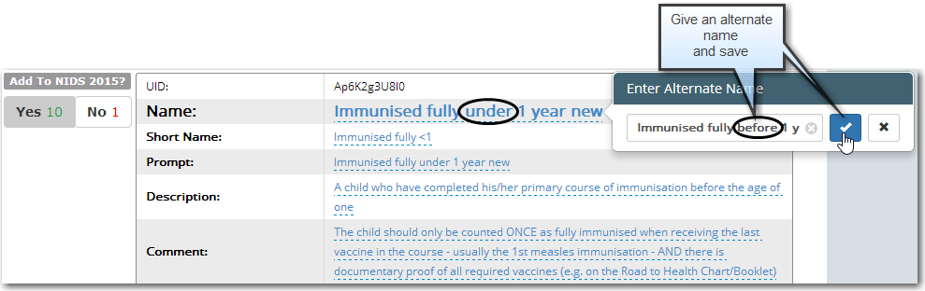
After saving it the page will refresh automatically and save your recommendation at the bottom of the page.
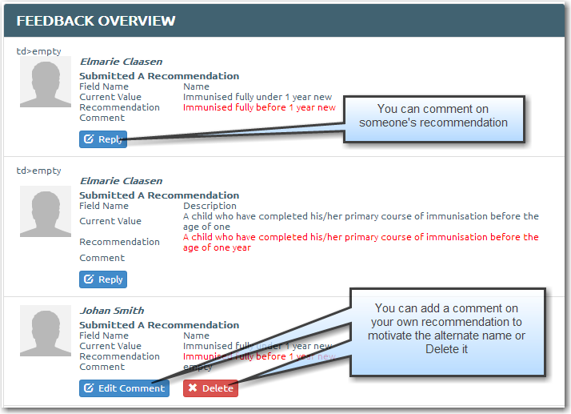

- Add new Indicators and Data elements
Only NDoH administrators are allowed to add new Indicators and Data elements.
Provinces do not have the authority to use this function.
